Update from Hampshire County Councillor Jan Warwick

June 2025

HCC Annual Council

At the annual council meeting at Hampshire County Council Cllr Nick Adams-King was elected as Leader of the Council.

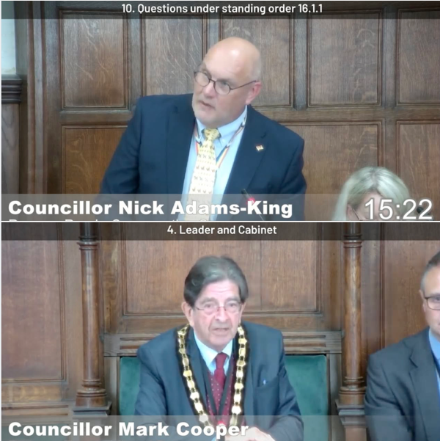
Councillor Mark Cooper, from Romsey Town as Chairman of the Council, the first Liberal Democrat Chairman for many years.

Cllr Adams-King said, "The County Council is like an oil tanker. With a £3.1 billion budget and almost 36,000 direct and indirect employees. When you turn the wheel, it takes a long time for the ship to react.
It takes time to move that organisation. We are doing so. We are effecting change. Change for the better. Change which shows us there is a way forward. One which takes us to a better, more prosperous, sustainable future.

Under my leadership, we are an efficient, caring, innovative, business friendly council.

We are changing this Council for the better. We are and will continue to make it work more effectively for the people of Hampshire. We are finding and making even more efforts to introduce innovative solutions, to work efficiently and to maximise the contribution from our assets.

We can now see a way ahead. The tanker is changing course. There is much left to do, but we can be optimistic for our future. We can see a way forward to address our financial challenge. To transform our organisation. To deliver growth and prosperity for our businesses and residents

Together we are delivering a positive future for Hampshire."

£7 Million Boost for Skills Training in Hampshire

Hampshire County Council has secured £7 million from the Department for Education to continue Skills Bootcamps for another year.

Fast-track training for adults aged 19+
Flexible courses in AI, leadership, data, teaching, sales & more
Guaranteed job interviews for unemployed learners
Over 1,750 places available in 2025
Designed around real employer needs

This is a brilliant way to help local people gain skills for life while supporting Hampshire’s businesses to grow and thrive.

Learn more and apply: hants.gov.uk/business/skillsbootcamp
Connect to Support Hampshire

Connect to Support Hampshire is the service which is designed to help people remain living independently in their own homes.

HCC have recently updated the Connect to Support Hampshire website to help residents stay independent for longer.

Modern Design: Enjoy a fresh, contemporary look.

Improved Navigation: Enhanced homepage navigation with popular search topics. Use keywords for better search results.

Expanded Community Directory: Now covering 63 towns and villages across Hampshire, including a new Younger Adults category.

Marketplace Directory: Find paid services like podiatrists, financial advisers, handypersons, gardeners, and more.

Home Care Directory: Home care and nursing care agencies in Hampshire.

Care Home Directory: Care homes and nursing homes in Hampshire.

Multilingual Support: Translate everything into different languages using Google Translate.

https://www.connecttosupporthampshire.org.uk/

Visit the site here to explore all the new features:

Local Government Reorganisation – securing a strong future for Hampshire and the Solent. This is the link to the page with the latest updates on the Devolution and LGR process underway across Hampshire and the Isle of Wight.
https://www.hants.gov.uk/News/20250513LGRstrongfuture
Consultation: Local Nature Recovery Strategy -please have your say on proposals to help nature recover across Hampshire (you can comment on this strategy up to 23 June).
https://www.hants.gov.uk/News/20250516LNRS

Cllr Jan Warwick
Winchester Downlands Division
Deputy Leader
Hampshire County Council
Jan.warwick@hants.gov.uk
07717 104236

